Look Beyond the Hits: Portugal. The Man
Ally Benisek
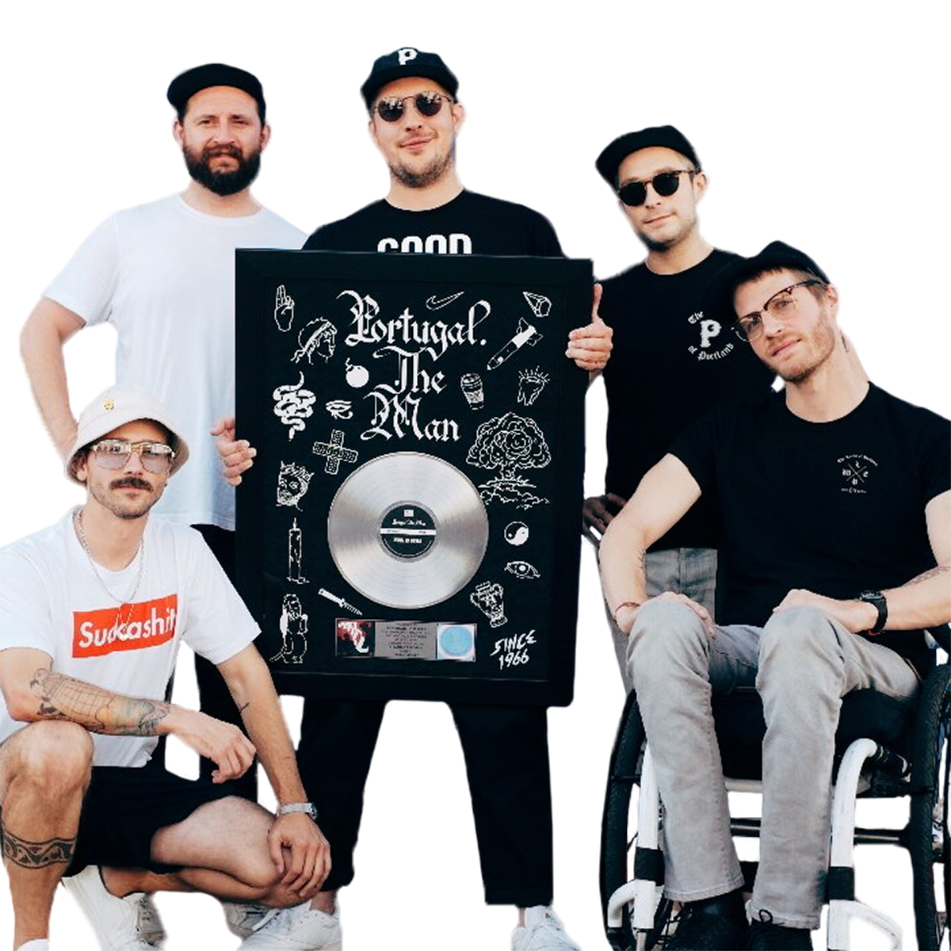
You have probably heard it on the radio a dozen times already, “Feel It Still” by “Portugal. The Man” has been topping charts since its release last year. However, the band itself has not reached the notoriety of being a household name among others in the pop industry.

The Alaskan born band was formed in 2004 by vocalist and guitarist John Gourley. Originally, the band was created as a side project, but eventually flourished after Gourley’s main project fell through. The name “Portugal. The Man” is based upon the idea of David Bowie’s “bigger than life” image. The members wanted the band to have a larger-than-life feel without the title focusing on one specific band member.

The reason they chose a country as their title was, as Gourley explains it, because “a country is a group of people. With Portugal, it just ended up being the first country that came to mind. The band's name is 'Portugal'. The period is stating that, and 'The Man' states that it's just one person.” Obviously, the band consists of many people, but the idea of a singular man takes the focus off of the people and delivers it to the band as a whole.

The modern rock band has many different genre influences and resembles the sounds of band such as Tame Impala, Cage the Elephant, and Haim. At first, their music could be mistaken for your everyday indie rock/pop material, however the band incorporates psychedelic and experimental aspects that separates their sound from the crowd.

While their hit, “Feel It Still” proved to be one of the best songs of the year, do not let it solely define their sound. Many of their albums contain songs with pleasantly unexpected twists and genre-bending additions. “Portugal. The Man’s” diversified sound stretches the definition of rock music while maintaining a classic rock base.

To get a better sense of “Portugal. The Man,” check out “So Young,” “So American,” “Creep In A T-Shirt,” and “Smile.”

While the band will not be hitting Atlanta (as of now) this year, they are set to headline Gulf Shore’s Hangout Fest on May 18.

